Experiment: 5
Simulation and Throughput Analysis of LTE-Advanced Carrier Aggregation

Objective – 1: Model One Component Carrier
Define a single LTE-Advanced component carrier and estimate its throughput for a selected
bandwidth and spectral efficiency.

MATLAB Program
clc; clear; close all;
BW1 = 20; % Component carrier bandwidth (MHz)
SE = 4; % Spectral efficiency (bits/s/Hz)
Ncc = 1; % Number of component carriers
BWagg = BW1*Ncc;
Throughput = BWagg*SE; % Mbps for MHz × bits/s/Hz
disp('Single Component Carrier')
disp(['Bandwidth = ',num2str(BWagg),' MHz'])
disp(['Estimated Throughput = ',num2str(Throughput),' Mbps'])
figure
bar(Ncc,Throughput)
grid on
xlabel('Number of Component Carriers')
ylabel('Estimated Throughput (Mbps)')
title('LTE-Advanced Single Carrier Throughput')

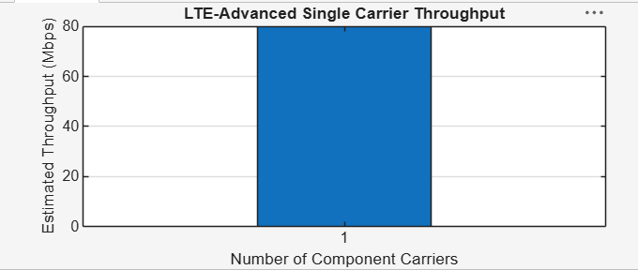
Single Component Carrier
Bandwidth = 20 MHz
Estimated Throughput = 80 Mbps

Objective – 2: Extend to Multiple Aggregated Component Carriers
Aggregate multiple component carriers and determine the resulting total bandwidth and
estimated throughput.
L
MATLAB Program
clc; clear; close all;
BWcc = 20; % MHz per component carrier
SE = 4; % bits/s/Hz
CC = [1 2 3]; % Number of component carriers
AggBW = BWcc .* CC; % MHz
Throughput = AggBW .* SE; % Mbps
disp('CC Aggregated BW (MHz) Estimated Throughput (Mbps)')
disp([CC' AggBW' Throughput'])
figure
bar(CC,Throughput)
grid on
xlabel('Number of Aggregated Component Carriers')
ylabel('Estimated Throughput (Mbps)')
title('LTE-Advanced Carrier Aggregation Throughput')

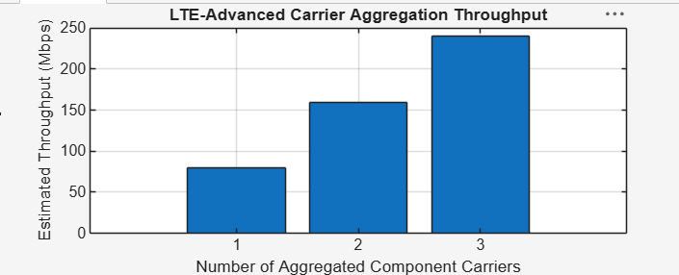
CC Aggregated BW (MHz) Estimated Throughput (Mbps)
1 20 80
2 40 160
3 60 240

Objective – 3: Compare Estimated Throughput for Different Carrier Bandwidths

MATLAB Program
clc; clear; close all;
BW = [5 10 15 20]; % Carrier bandwidths (MHz)
SE = 4; % bits/s/Hz
TP = BW .* SE; % Estimated throughput (Mbps)
disp('Bandwidth (MHz) Throughput (Mbps)')
disp([BW' TP'])
figure
plot(BW,TP,'o-','LineWidth',2)
grid on
xlabel('Carrier Bandwidth (MHz)')
ylabel('Estimated Throughput (Mbps)')
title('Throughput vs Component Carrier Bandwidth')
Expected Output: Throughput increases as the component-carrier bandwidth increases.
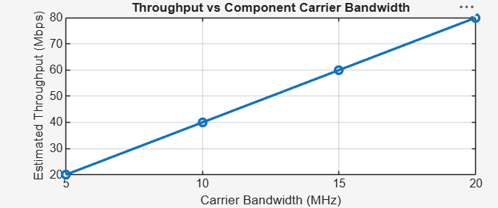
Objective – 4: Explain the Effect of Carrier Aggregation
The total available bandwidth is obtained by combining the component carriers. Under the
simplified constant spectral-efficiency model, throughput increases approximately in
proportion to the aggregated bandwidth.
Result
1. The LTE-Advanced link was successfully modeled using a single component carrier.
2. Multiple component carriers were aggregated and the resulting bandwidth and estimated
throughput was calculated.
3. Throughput was compared for different carrier bandwidths.
4. The simulation demonstrated that carrier aggregation increases available transmission
bandwidth and can increase achievable throughput.

